Chapter 7 Solutions and Spectroscopy name: class:
考点 A: 溶解度 (Solubility)
1. 掌握溶解度的"相似相溶"原理
"Like dissolves like": polar solutes dissolve in polar solvents; nonpolar solutes dissolve in nonpolar solvents
NaCl(s) is soluble in water (ion-dipole interactions) but not in hexane (nonpolar, London only)

1. Methanol (CH₃OH) is completely miscible with water because: （ ）
A both are nonpolar.
B methanol can form hydrogen bonds with water.
C methanol is ionic.
D methanol has a low molar mass.

2. Under which condition is a solution most likely to form? （ ）
A. When solvent-solute interactions are weaker than solvent-solvent interactions.
B. When solvent-solute interactions are stronger than solvent-solvent interactions.
C. When solute-solute interactions are stronger than solvent-solvent interactions.
D. When all interactions (solvent-solvent, solute-solute, and solvent-solute) are equally strong.

3. Which of the following diagrams represents a heterogeneous mixture? （ ）
A. All particles are identical and evenly spaced throughout (pure element)
B. Different particles evenly distributed at molecular level (homogeneous mixture)
C. Different particles grouped into distinct regions (heterogeneous mixture) ✓
D. Particles chemically bonded in fixed ratio (compound)

考点 B: 溶液浓度表示 (Solution Concentration)
1. 物质的量浓度 M = n/V (n = moles of solute, V = liters of solution)
2. 稀释定律: M₁V1 = M₂V2
3. 离子浓度：注意化学式中离子的化学计量数（如 Ba(OH)₂ → Ba²⁺ + 2OH⁻）

1. Which of the following statements about solutions is incorrect? （ ）
A. A solution is a homogeneous mixture.
B. The solvent is always the component in the largest amount.
C. Adding solvent changes the number of moles of solute.
D. Molarity expresses concentration as moles of solute per liter of solution.

2. Which of the following describes the correct procedure to prepare 0.25 L 0.100 M Na₂CO₃ (aq)? (The molar mass of Na₂CO₃ is 106 gmol-1) （ ）
A. Dissolve 1.06 g of Na₂CO₃ (s) in a small amount of distilled water and dilute to 0.25 L.
B. Dissolve 2.65 g of Na₂CO₃ (s) in a small amount of distilled water and dilute to 0.25 L.
C. Add 1.06 g of Na₂CO₃ (s) to 0.25 L of distilled water.
D. Add 2.65 g of Na₂CO₃ (s) to 0.25 L of distilled water.

3. A 5.23 g sample of anhydrous K₂SO₄ (molar mass 174.3 gmol-1) is dissolved in 1.75 L of solution.
What is the molarity of the solution, to three significant figures? （ ）
A. Option A
B. Option B
C. Option C
D. Option D

4. Which of the following solutions contains the greatest number of moles of Cl- ions? （ ）
A. 25 mL of 0.10 M CaCl₂
B. Option B
C. 20 mL of 0.20 M SrCl₂
D. Option D

5. A 50.2 g sample of barium hydroxide is dissolved in 1.25 L of solution.
What is the concentration of hydroxide ions, to three significant figures? （ ）
A. Option A
B. Option B
C. Option C
D. Option D

6. Ascorbic acid has the chemical formula C₆H₈O₆.
How many millilitres of a 0.0653 M solution of ascorbic acid would be required to obtain 4.90 g of ascorbic acid? （ ）
A. Option A
B. Option B
C. Option C
D. Option D

7. Equal volumes of solutions in two different vessels are represented above. (Water molecules are not shown).
If vessel 1 represents a CaCl₂ (aq) solution, then vessel 2 could represent an aqueous solution of （ ）
A. CaCl₂ with the same molarity as the solution in vessel 1.
B. CaCl₂ with half the molarity of the solution in vessel 1.
C. KCl with the same molarity as the solution in vessel 1.
D. KCl with half the molarity of the solution in vessel 1.

考点 C: 溶液分离 (Separation of Solutions)
1. 掌握色谱分析（Rf 值）
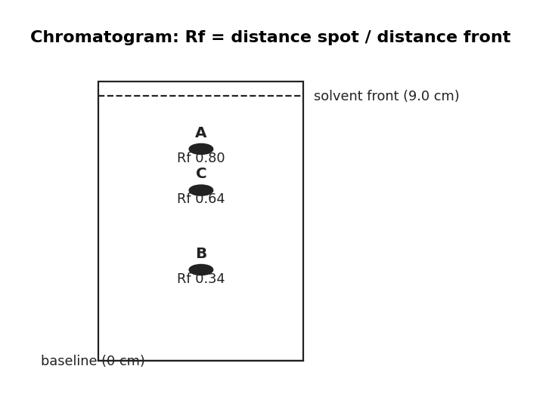
图 C₀7-1：色谱 Rf 示意图（对应考点 C 色谱分析 / MCQ6）
Rf = distance traveled by component / distance traveled by solvent front
Higher Rf → stronger affinity for mobile phase; Lower Rf → stronger affinity for stationary phase
蒸馏 (Distillation): 利用沸点（蒸气压）差异分离互溶液体
色谱法 (Chromatography): 利用极性与流动相/固定相亲和力差异分离

1. Dye X travels 5.1 cm, dye Y travels 2.6 cm, solvent front 8.5 cm.
Which dye has stronger affinity for the stationary phase? （ ）
A Dye X (Rf = 0.60)
B Dye Y (Rf = 0.31)
C Both have equal affinity.
D Cannot be determined.

2. A chromatogram of two compounds, A and B, is shown above. The Rf value of compound B is （ ）
A. Option A
B. Option B
C. Option C
D. Option D

3. The distance that an amino acid moves on a chromatogram depends on （ ）
A. the intermolecular forces between the amino acid and the stationary phase.
B. the intermolecular forces between the amino acid and both the mobile and stationary phases.
C. the intermolecular forces between the solvent and the stationary phase.
D. the intermolecular forces between the solvent and both the mobile and stationary phases.

4. A sample of cyclohexene contaminated with cyclohexanol is separated by column chromatography.
Hexane is used as the mobile phase and silica gel as the stationary phase.
Which statement correctly explains why cyclohexene has a shorter retention time than cyclohexanol? （ ）
A. Cyclohexene and cyclohexanol have different polarities.
B. Cyclohexene is polar due to the C=C.
C. Cyclohexanol is held in the mobile phase for longer.
D. Cyclohexanol can form hydrogen bonds with the silica gel.

5. Four pure dyes, A through D, are spotted on chromatography paper as indicated in the diagram below.
An unknown dye, X, is spotted on a separate piece of chromatography paper.
Both papers are then developed in chromatography chambers.
The developed chromatograms are shown above.
Based on the results of the paper chromatography experiment, which of the four dyes is most likely to be dye X? （ ）
A. Graph A
B. Graph B
C. Graph C
D. Graph D

6. A student obtains a mixture of the liquids pentane (C₅H₁₂, bp 36°C, density 0.63 g/mL) and heptane (C₇H₁₆, bp 98°C, density 0.68 g/mL), which are miscible in all proportions.
Which of the following techniques would be best for separating the components of this mixture, and why? （ ）
A.
Distillation, because the liquids would boil at different temperatures owing to the difference in strength of their intermolecular forces.
B.
Filtration, because the different densities of the liquids would allow one to pass through the filter paper while the other would not.
C.
Column chromatography, because the higher molar mass of octane would cause it to move down the column faster than hexane.
D.
Paper chromatography, because the liquids would move along the stationary phase at different rates owing to the difference in polarity of their molecules.

7. A thin-layer chromatography (TLC) experiment was conducted using a silica gel-coated TLC plate (a polar material) and a solvent mixture of 95% dichloromethane (DCM) and 5% methanol.
The sample mixture contained two polar food additives.
The relative polarities of the solvents used in this and similar experiments are:
Chloroform 0.26DCM 0.31Methanol 0.76 Based on this information, which change to the solvent mixture would likely increase the Rf values of the food additives in a subsequent experiment? （ ）
A. Decreasing the percentage of methanol.
B. Increasing the percentage of methanol.
C. Replacing DCM with chloroform.
D. Replacing methanol with chloroform.

1. A mixture of three components is separated by paper chromatography using a nonpolar solvent.
Solvent front = 9.0 cm. A travels 7.2 cm, B travels 3.1 cm, C travels 5.8 cm.
(a) Calculate Rf for component B. [1 mark]
(b) Rank the components from most polar to least polar. Justify. [2 marks]

考点 D: 光谱分析 (Spectroscopy)

1. 掌握 Beer-Lambert 定律 A = εbc
A = absorbance (no units), ε = molar absorptivity (M⁻¹cm⁻¹), b = path length (cm), c = concentration (M)
Calibration curve: plot A vs c for standards → unknown concentration from its A
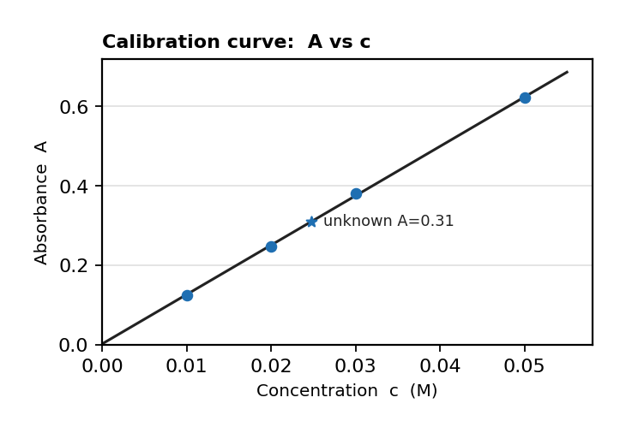
图 C₀7-3：校准曲线 A vs c（对应考点 D 校准曲线 / FRQ1）
Measure at λ_max for best sensitivity and lowest error
Spectrophotometer procedure: (1) turn on and warm up, (2) set wavelength to λ_max, (3) blank with solvent (zero absorbance), (4) measure standards and unknown
Cuvette technique: handle by frosted sides only (fingerprints on transparent sides absorb light → apparent A too high)
Rinse cuvette with the solution to be measured before filling (residual water dilutes → apparent A too low)
Always orient cuvette the same way (transparent sides toward light path)
2. 电磁波谱 (Electromagnetic Spectrum): 不同波长对应不同能量区域（紫外、可见光、红外等）
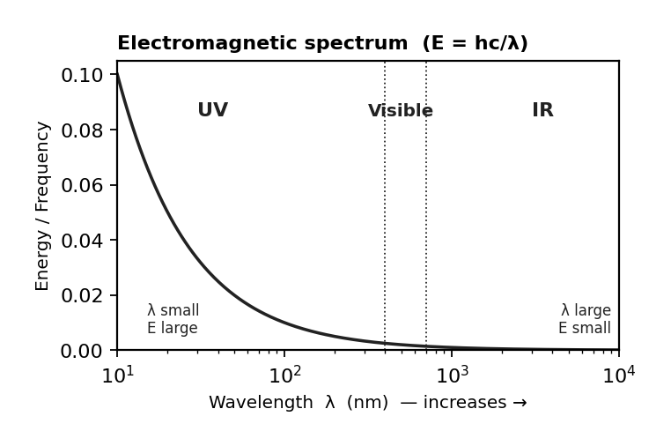
图 C₀7-2：电磁波谱（对应考点 D 光谱分析 / MCQ8）
UV-Vis absorption: causes electronic transitions (electrons jump to higher energy levels)
IR absorption: causes molecular vibrations (bonds bend and stretch); different functional groups absorb at characteristic wavelengths
IR spectroscopy can identify functional groups (C=O, O-H, N-H) by their characteristic absorption frequencies
3. 光子能量: E = hν = hc/λ (h = 6.626 × 10⁻³⁴ J·s)

1. Why should absorbance be measured at λ_max? （ ）
A The solution is transparent at that wavelength.
B Maximum sensitivity and lowest relative error.
C All solutions absorb equally at that wavelength.
D To avoid interference from the solvent.

2. A student dilutes a colored solution by a factor of 2. How does the absorbance change? （ ）
A It doubles.
B It is halved.
C It stays the same.
D It quadruples.

3. A student neglects to wipe fingerprints off the transparent side of the cuvette before measuring absorbance.
How will this affect the measured absorbance? （ ）
A The measured absorbance will be too high, because the fingerprints absorb some light.
B The measured absorbance will be too low, because the fingerprints reflect light back to the detector.
C The measured absorbance will be unaffected, because fingerprints do not interact with light.
D The measured absorbance will be too low, because the fingerprints dilute the solution.

4. A student incorrectly orients the cuvette so that the light path passes through the frosted sides instead of the transparent sides.
How will this affect the measured absorbance? （ ）
A The measured absorbance will be higher than the actual value, because the frosted sides scatter and absorb light.
B The measured absorbance will be lower than the actual value, because the frosted sides allow more light to pass through.
C The measured absorbance will be unaffected, because the cuvette material is the same on all sides.
D The measured absorbance will be zero, because no light can pass through frosted glass.

5. After rinsing a cuvette with distilled water, the student forgets to rinse it with the dye solution before filling.
Some water droplets remain in the cuvette.
How will this affect the measured absorbance? （ ）
A The measured absorbance will be too high.
B The measured absorbance will be too low, because the solution is diluted by the residual water.
C The measured absorbance will be unaffected.
D The measured absorbance will be zero.

6. Which of the following best explains what occurs at the molecular level when a molecule absorbs infrared radiation? （ ）
A Electrons in the molecule jump to higher energy orbitals.
B The atoms in the molecule increase their vibration as the bonds between them bend and stretch.
C The molecule breaks apart into its constituent atoms.
D The molecule begins to rotate faster about its axis.

7. A colored solution is analyzed by spectrophotometer.
The solution has concentration 0.2 M and path length 1.00 cm.
When the filter of the spectrophotometer is set to 430 nm, the absorbance is x.
If the experiment is repeated using a cuvette with 0.5 cm path length deduce the new absorbance. （ ）
A. The absorbance will double (A' = 2A) because path length is halved
B. Option B
C. Option C
D. Option D

8. The wavelength range for ultraviolet radiation is 10-8 m, while that of infrared radiation is 10-5 m.
Which type of radiation has more energy, and why? （ ）
A. Infrared has more energy because it has a lower frequency.
B. Infrared has more energy because it has a shorter wavelength.
C. Ultraviolet has more energy because it has a higher frequency.
D. Ultraviolet has more energy because it has a longer wavelength.

9. If the frequency of a photon of electromagnetic radiation is 5.0 x10¹⁴ Hz, determine the energy of the photon. （ ）
A. Option A⁻¹⁹ J
B. Option B⁻¹⁹ J
C. Option C⁻¹⁹ J
D. Option D⁻¹⁹ J

10. Identify the type of energy transition shown in the diagram （ ）
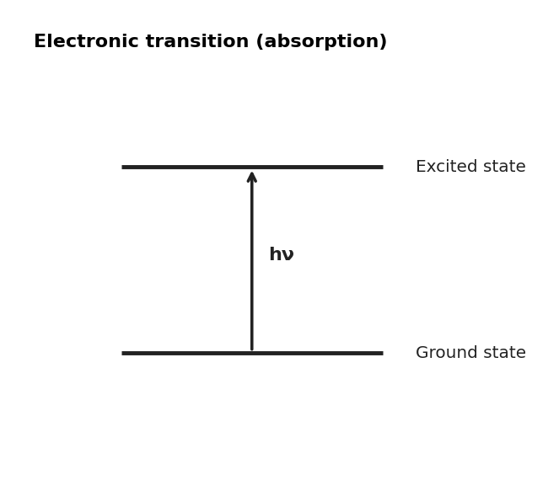
图 C₀7-4：能级跃迁图（对应考点 D MCQ10）
A. Diagram A — particle arrangement
B. ultraviolet radiation
C. Diagram C — particle arrangement
D. visible light radiation

11. Which of the following provides the best explanation for what occurs when dye molecules absorb photons of visible light? （ ）
A.
Certain electrons in the dye molecule transition to a higher energy level, with the energy difference between the two levels matching the energy of the absorbed photons.
B.
Certain chemical bonds in the dye molecules start to bend and stretch, with the energy difference between the lower and higher vibrational states equaling the energy of the absorbed photons.
C.
The dye molecules begin to rotate more rapidly in specific modes, with the energy difference between the lower and higher rotational states matching the energy of the absorbed photons.
D.
Certain covalent bonds in the dye molecules begin to break and re-form, with the bond energies of the bonds being the same as the energy of the absorbed photons.

12. Determine the amount of energy in joules that a carbon dioxide molecule gains when it absorbs a photon of infrared radiation of wavelength 7 x10-7 m. （ ）
A. Diagram A — particle arrangement⁻¹⁹ J
B. Diagram B — particle arrangement⁻¹⁹ J
C. Diagram C — particle arrangement⁻¹⁹ J
D. Option D⁻¹⁹ J

13. A student creates a calibration curve of relative absorbance of a fixed wavelength of light for different concentrations of nickel(II) ions.
In a further experiment, they want to use the calibration curve to determine the number of moles of nickel(II) sulfate in a 150 mL sample of a solution of nickel(II) sulfate of unknown concentration.
The unknown solution is measured and found to have a relative absorbance of 0.6.
Determine the number of moles present in the sample. （ ）
A. Graph A
B. Graph B
C. Graph C
D. Graph D

14. The photoelectron spectra for hydrogen (H) and helium (He) are shown above.
Which of the following explanations best accounts for the peak in the He spectrum being positioned farther to the left and higher than the peak in the H spectrum? （ ）
A. He has an additional valence electron in a higher energy level than the valence electron in H.
B. He has a greater nuclear charge than H and an additional electron in the same energy level.
C.
He has a completely filled valence shell in which the electrons are a greater distance from the nucleus than the distance between the H nucleus and its electron.
D. It takes longer for the electrons in He to be removed due to the higher nuclear mass of He.

15. Electromagnetic radiation with a maximum wavelength of 540 nm is required to study the photoelectric effect in potassium atoms.
What is the approximate frequency associated with this wavelength? （ ）
A. Option A⁻¹
B. Option B⁻¹
C. Option C⁻¹
D. Option D⁻¹

1. CuSO₄ standards: c=0.0100M A=0.125; c=0.0200M A=0.248; c=0.0300M A=0.380; c=0.0500M A=0.622; b=1.00cm.
(a) Determine ε from the data. [2 marks]
(b) An unknown has A=0.310. Find its concentration. [1 mark]

